Calculus 1 Name Block Date
Practice: Criteria Graphing, Mean Value Theorem, Min/Max Existence Theorem

1. Sketch a graph of the function from the given information.

State the extreme values and their type.

2. Answer the following questions using the given graph. (values will all be approximate)
:
:
:
:
Extreme Values:
Points of Inflection:
Discontinuities:

Does the Mean Value Theorem apply for the given interval? If so, calculate the value(s) of c. If not, state the reason why.
3) 4)

5) 6)

Does the Mean Value Theorem apply for the given interval? If so, calculate the value(s) of c. If not, state the reason why.
7) 8)

9) 10)

Using the Min/Max Existence Theorem determine the minimum and maximum values.
11) 12)
Label the absolute max and min on the graph.
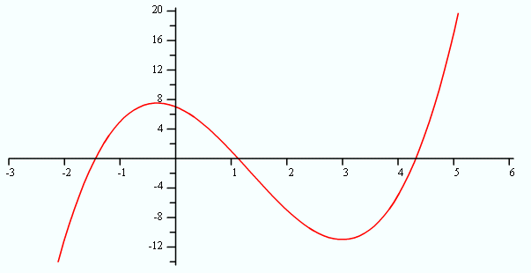

13) 14)

